Workforce Development

in the Care Economy and Beyond:

Challenges, Gaps, and Strategic Opportunities

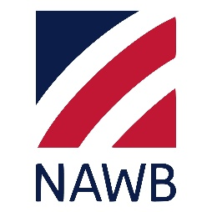

Executive Summary
The care economy is a rapidly growing field in which trained professionals support individuals faced with physical, mental and societal challenges. The U.S. Bureau of Labor Statistics expects an average of 16% growth over the next ten years across the youth development, peer support and substance use disorder and mental health counseling fields. The question for workforce development boards is how to engage in this growing field.
The National Association of Workforce Boards (NAWB), as a leader in the workforce development system, assists its members to align and scale registered apprenticeship efforts across regions. NAWB is partnering with FHI 360’s National Institute for Work and Learning (NIWL) on an Apprenticeship Building America, Round 2 (ABA2) grant, funded by the U.S. Department of Labor (DOL), to strengthen, modernize, expand, and diversify Registered Apprenticeship Programs (RAPs) in the care economy. The Promising Leaders Apprenticing in the Care Economy Hub created under the ABA2 grant, is addressing the workforce needs of this evolving industry sector.
Workforce development systems—particularly in sectors under the care economy such as behavioral health, addiction services, and advanced manufacturing—face persistent structural challenges that limit their effectiveness. Key barriers include misalignment between education and employer needs, fragmented funding and governance systems, regulatory constraints, and weak cross-sector collaboration. This brief provides workforce development boards (WDBs) with an overview of the care economy landscape, the emerging workforce challenges, and the strategic role WDBs can play—both individually and in partnership with employers, educational institutions, and economic development organizations. It highlights labor market realities, outlines Registered Apprenticeship-based solutions, and presents real-world examples of successful regional collaboration. For WDBs, proactive engagement with employers is not only a solution to talent shortages but also a competitive advantage in a rapidly expanding sector.
Insights from practitioner discussions highlight that successful workforce initiatives depend less on creating new programs and more on aligning existing systems, strengthening partnerships, and shifting toward skills-based, employer-informed pathways. Without structural coordination, even well-funded initiatives struggle to achieve scale or sustainability. The guidance and recommendations included in this brief are built on the experiences of several local workforce development boards. NAWB is very appreciative to:
- James Disbro, Senior Director, Regional Alignment & Programs Development, CareerSource Suncoast, Florida
- Gina Caronna, President & CEO, The Workforce Connection, IL
- Jennifer Serino, Director, Lake County Workforce Development Board, IL

The Growing Importance of the Care Economy

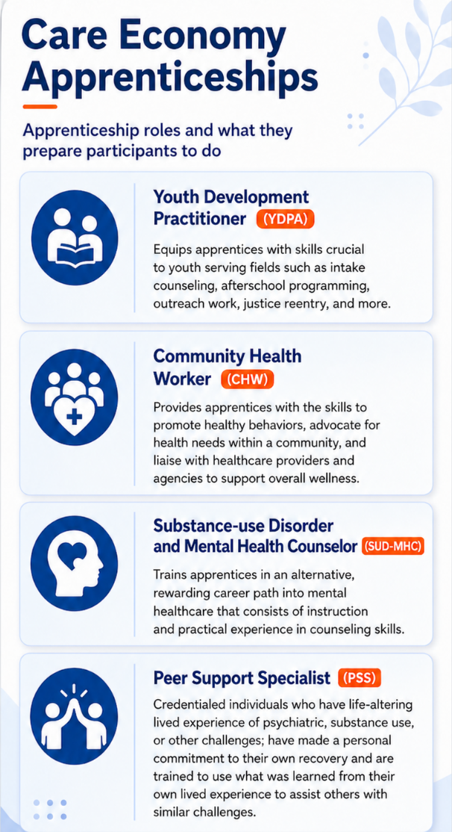
The Care Economy is a rapidly growing field in which trained professionals support individuals faced with physical, mental, and societal challenges. The U.S. Bureau of Labor Statistics expects an average of 16% growth across the youth development, peer support, and substance use disorder and mental health counseling fields from 2023 to 2033. The NIWL ABA2 initiative, funded by the DOL, is the only apprenticeship grant focused on youth development, mental health, and expanding care economy careers for those with lived experience (such as recovery from substance-use disorder). Promising Leaders Apprenticing in the Care Economy Hub creates affordable pathways to entry, incorporates the voices of lived experiences, and provides opportunities to earn while learning in care economy professions. These include pre-apprenticeship curriculums and four apprenticeship pathways. Four (4) apprenticeship programs have been developed and include:
- Youth Development Practitioner (YDPA)
- Community Health Worker
- Substance Use Disorder and Mental Health Counselor
- Peer Support Specialist

In addition, pre-apprenticeship curricula focused on mental health and youth development have been developed.

Challenges and Solutions to Meet the Needs of the Care Economy

Conversations with local workforce development boards that provide work-based training (especially apprenticeships) highlighted the challenges and barriers that many local WDBs are facing while also identifying potential solutions to address these challenges.
- Sector-Specific Constraints: Peer Support Specialist Workforce
The behavioral health and addiction recovery workforce illustrates the complexity of workforce development in highly regulated environments. Workforce development in the care economy requires integration with existing systems, not parallel program creation. Programs developed in isolation are unlikely to succeed due to regulatory and operational realities.

Potential Challenges include:
- Regulatory barriers: Insurance requirements impose strict experience and credentialing standards, limiting entry pathways.
- Operational constraints: High caseloads and staffing shortages reduce capacity for training and supervision.
- Training limitations: Traditional models such as On-the-Job Training (OJT) and Work Experience (WEX) are difficult to implement due to:
  - Required supervision ratios
  - Compliance requirements
  - Risk management concerns

Program Design Challenges in Local Workforce Systems
- Efforts to design workforce programs reveal a consistent disconnect between training systems and employer needs.
- Educational misalignment: Training programs often fail to reflect real-world job requirements.
- Credential inflation: Increasing educational requirements create barriers without improving job readiness.
- Fragmentation: Workforce boards, colleges, and employers operate under separate mandates.
- Structural Tension - Community colleges and workforce boards often compete rather than collaborate due to:
  - Different funding streams
  - Distinct accountability metrics
  - Governance misalignment
- Systemic Collaboration Failures in Education and Training - A recurring theme highlighted by the workforce boards interviewed included the lack of coordinated strategy across education and workforce systems.

Notable Solutions

CareerSource Suncoast (CareerSourceSC) in Sarasota, FL utilizes labor market data to identify key growth areas and, as a result, began working with educational institutions and employers in the disaster recovery and opioid occupational areas. In addition, CareerSourceSC has worked to train county administrators which has led to the implementation of county incentives to broaden the reach of apprenticeship programs.

Workforce Connection in Rockford, IL, connected with an employer-led apprenticeship program—developed in partnership with post-secondary institutions and approved by the Illinois Board of Higher Education—that demonstrates that industry-driven design improves outcomes.
The Lake County Workforce Board in IL emphasized the importance of WDBs as a central hub for stakeholders involved in work-based training. Through WDBs, employers can be connected with apprenticeship opportunities, and collaboration with educational institutions can be encouraged by providing an understanding of the connection between academic training and workforce development. The Lake County Workforce Board has engaged in the care economy through an apprenticeship expansion grant, which included hiring a specialist focused on this area and participating in international knowledge.

Partnership and Accountability Misalignment - Multi-stakeholder workforce initiatives face significant coordination challenges.

Core Issues and Barriers
- Conflicting metrics: Different organizations measure success differently (e.g., enrollments vs. job placements).
- Funding silos: Separate funding streams discourage integration.
- Operational complexity: Managing partnerships requires continuous alignment across stakeholders.
- Inefficient funding allocation: Grants are distributed across institutions without enforced collaboration.
- Inconsistent program quality:
  - For-profit training programs are often more expensive and restrictive
  - Credit-based programs may be more accessible but slower to adapt
- Weak enforcement mechanisms: Collaboration requirements in grants are often nominal rather than operational.
Positive Model - Sustained, informal collaboration mechanisms may be more effective than formal mandates alone. Effective partnerships require:
- Shared metrics
- Unified goals
- Integrated accountability frameworks
Lake County Workforce Board addressed the issue of frequent leadership changes and existing internal training programs. The WDB adopted an approach to supporting young people through pre-apprenticeship training and onboarding, including partnerships with high schools and initiatives like bringing employers into schools to discuss entry-level job opportunities. They also launched a program with City of Hope cancer treatment center that allows high school students to work in the hospital's kitchen as an introduction to the healthcare environment.

Workforce Connections addressed challenges such as insurance regulations and busy workloads as they put into place programs to train peer support specialists in addiction and mental health. The WDB understands that effective workforce development in the care economy requires strong partnerships with existing players in these fields rather than developing programs in isolation. Workforce Connections also joined a regional task force that created a mental health board and included the regional economic development agency. The Task force understood the complexity of the mental health field and focused on career pathways in mental health care.

CareerSource Suncoast has put into place initiatives that educate employers on the benefits of utilizing apprenticeship programs and how this strategy increases an employer’s ROI. In addition, CareerSource Suncoast has worked to strengthen the regional collaboration related to training and hiring and has hosted numerous regional events. These efforts have led to local workforce boards recognizing the opportunities before them and the issues they can address in their local business community.
Frequent policy changes—regardless of political leadership—undermine long-term program stability and effectiveness.
Rethinking Education-to-Work Pathways - Traditional linear education pathways are increasingly misaligned with labor market needs.

Identified Gaps
- Degrees do not consistently signal job readiness
- Employers struggle to articulate required skills
- Learners lack clear, flexible pathways to employment

Emerging Approach: Skills-Based Pathways
A more effective model includes:
- Modular learning across multiple platforms:
  - Community colleges
  - Online education providers
  - Industry certifications
- Employer-defined skill requirements
Shifting from credential-based to skills-based systems improves transparency and alignment.
Lake County Workforce Development Board worked with FHI 360 to bring the Youth Development Practitioner Apprenticeship Program to Lake County, resulting in nearly 20 apprentices over three years. The initiative emphasized the importance of sharing resources and making direct connections with intermediaries who understand specific challenges.

Strategic Direction for Workforce Development

Workforce Development Boards serve as critical intermediaries between employers, job seekers, educators, and public funding systems. Their mission is to ensure that workforce investments align with regional economic needs while creating pathways to family-sustaining employment. WDBs are uniquely positioned to:

• Analyze labor market data to identify current and emerging skill needs.

• Convene employers, training providers, and economic development partners.

• Leverage public funding to offset training costs for businesses.

• Support incumbent worker upskilling and career advancement.

Key Strategic Priorities

1. Shift to Skills-Based Frameworks
- Define competencies required for specific roles
- Align training providers to those competencies

2. Strengthen Industry Partnerships
- Engage employers as co-designers of curriculum
- Utilize industry organizations (e.g., National Coalition of Certification Centers (NC3)) to standardize training

3. Simplify System Navigation
- Create clearer pathways linking:
  - Skills → Training → Credentials → Jobs
- Reduce duplication across programs

4. Align Incentives and Metrics
- Develop shared success measures across:
  - Education providers
  - Workforce boards
  - Employers

5. Improve Coordination Mechanisms
- Establish regular cross-sector convenings
- Encourage informal collaboration alongside formal structures

6. Focus on Implementation Capacity
- Invest in implementation, not just program design
- Ensure local institutions have the resources and incentives to deliver

Registered Apprenticeships as a Scalable Solution
Registered Apprenticeships are emerging as one of the most effective tools for addressing care economy workforce shortages. They combine paid, on-the-job learning with structured instruction, allowing businesses to develop talent aligned with their specific technologies and processes.
Pre-Apprenticeships and Early Talent Pipelines - Pre-apprenticeship programs can introduce care economy concepts within high school healthcare and human resources curricula. These programs build awareness while reducing onboarding time for employers.
Utilizing Existing Registered Apprenticeships – NIWL has care economy apprenticeships developed and approved by the USDOL Office of Apprenticeship. Rather than creating entirely new programs, WDBs can efficiently and effectively meet the growing needs of employers, educational institutions and other partners by bringing to the discussions the ability to move forward quickly by engaging with The Promising Leaders Apprenticing in the Care Economy Hub and their approved apprenticeships.
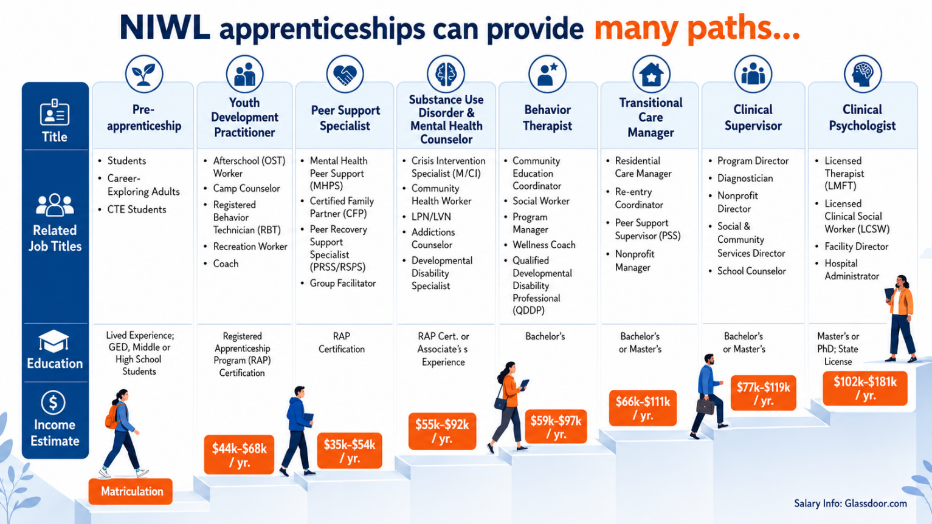

Conclusion
Current workforce development systems are constrained less by lack of funding or innovation and more by structural fragmentation and misalignment. The most effective path forward is not the proliferation of new programs, but the integration and alignment of existing systems around shared, skills-based goals.
Sustainable progress will depend on:
- Strong employer engagement
- Coordinated governance
- Clear accountability structures
- Practical, flexible pathways for learners
Without these shifts, workforce initiatives will continue to struggle to achieve scale, relevance, and long-term impact.
Resources:
NAWB Apprenticeship Webpage https://www.nawb.org/registered-apprenticeship-resource-hub/

NIWL’s Apprenticeships Resource Hub https://niwl.fhi360.org/apprenticeships/
DOL Office of Apprenticeship https://www.dol.gov/agencies/eta/apprenticeship
Federal Resources Playbook http://www,doleta/oa/federalresources/playbook/pdf

This brief is supported by the Employment Training Administration of the US Department of Labor (DOL) as part of an ABA2 grant award totaling $8 million with 0% financed from non-governmental sources. This workforce product was funded by a grant awarded by the U.S.​ Department of Labor (DOL)’s Employment and Training​ Administration. The product was created by the recipient and does​ not necessarily reflect the official position of DOL. DOL makes no​ guarantees, warranties, or assurances of any kind, express or implied,​ with respect to such information, including any information on linked​ sites and including, but not limited to, accuracy of the information or​ its completeness, timeliness, usefulness, adequacy, continued​ availability, or ownership. This product is copyrighted by the​ institution that created it.

