**What is Family-centered Employment (FCE)?**

FCE or Two Generation (2GEN) approaches focus on creating opportunities for and addressing the needs of both parents and children together. With a family-centered approach, workforce development, child care assistance, children’s education and adult education programs are linked together. This builds educational opportunities and a network of support to assist families with health and wellbeing, financial, housing, child care, and workforce services to create a foundation for success. Evidence shows that this leads to better employment outcomes as well as economic security and advancement of an employee and their family.

**Why is this important to you as an Employer?**

By working with FCE programs in your community, you will have access to employees that are receiving integrated support from Health and Human Services, Education, and Workforce organizations, prior to their first day on the job. They will have worked together to identify and address barriers to success at work, such as:

* Reliable housing and transportation to work
* Completed work readiness evaluation, training and preparation
* Children in high quality, stable child care, resulting in fewer absences and increased employee engagement from knowing their children are thriving while they are at work
* Financial stability through financial wellness programs.

These barriers keep many entry-level and hourly workers from being ready for success in your jobs. For instance, nearly one-third of parents (32 percent) report having difficulty finding child care,[1] resulting in missed days or reduced hours at work as well as reduced productivity at work due to distractions and added stress. The existence of any of these barriers in the 11 million parents working that have children under the age of three results in reduced productivity and increased turnover. They are also factors in missed employee training and teamwork building activities. Removing these barriers creates a more diverse, better prepared, and more effective talent pool for employers.

These barriers also have a significant impact on your business and the overall economy. A 2019 ReadyNation Report[2] found that the nation’s child care crisis has an annual economic cost of $57 billion in lost earnings, productivity and revenue, with employers losing $12.7 billion annually due to productivity problems resulting from child care challenges faced by their workforce.

Additional Information About Impacts and Outcomes:

* In a Wall Street Journal survey [3]of 900 business executives, 93 percent said that character skills were as important or more important than technical abilities, and 89 percent reported difficulties in finding employees with these skills.
* It is important for parents to have the skills needed to help children develop their character skills as they prepare for kindergarten. A 20-year study [4]examined the character skills of 800 kindergarteners and followed them until age 25. For every one point increase in children’s character skills scores in kindergarten, they were: 54 percent more likely to earn a high school diploma, twice as likely to attain a college degree, and 46 percent more likely to have a full-time job at age 25. Programs such as Parents as Teachers and Nurse Family Partnerships are available to help build these skills in parents, so they can build character skills in their children.
* Additional post-employment support has also proven successful, with an example being 85% of employees that work with Work-Life Partnership Navigators stay in their jobs.

The following data and graphics are available from ReadyNation to highlight the impact of child care problems. The findings are based on a survey of 812 working parents of children under age 3. The sampling frame includes all working parents—evenly split between mothers and fathers—across the U.S.

**Work Time:**

Child care problems significantly reduce how much time working parents can spend at work. On average parents lost 2 hours per week of work time (5 percent of their work week). The figures below shows how effort at work is disrupted over a 90 day time period because of child care problems:

* Almost two-thirds of working parents report leaving work early
* More than half of working parents report being late for work, missing a full day of work, or being distracted at work
* One-third of working parents report missing part of their daily work shift

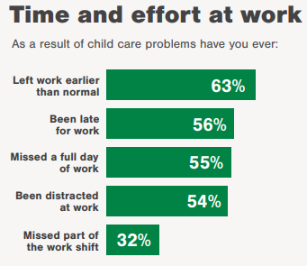

**Work Productivity:**

Child care problems substantially impair workers’ ability to be productive at work; this undermines their job stability. The figure below shows how job status is damaged because of child care problems:

* One-quarter of working parents report problems participating in education and training that would improve their productivity at work
* One-in-five working parents report being reprimanded by a supervisor
* One-in-seven working parents report having their pay or hours reduced
* Almost one-in-ten report working parents report either being demoted or transferred or being fired or let go; together, just over one-in-ten report a significant job disruption.

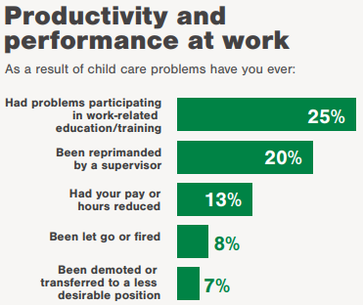

**Career Prospects:**

Child care problems adversely affect workers’ decisions about their careers; this results in diminished job prospects. Figure 3 shows how work opportunities are constrained because of child care problems:

* One-quarter of working parents report having to reduce their regular work hours, turn down further education or training, and turn down job offers
* One-in-six working parents report turning down a promotion or reassignment to a preferred job
* One-in-seven working parents report having their pay or hours reduced and quitting a prior job

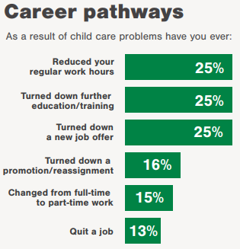

1. Child Trends (2016, May). DataBank: Child care. http://www.childtrends.org/wp-content/uploads/2016/05/21_Child_Care.pdf
2. ReadyNation, Want to Grow the Economy? Fix the Child Care Crisis.
3. Davidson, K. (2016, August 30). Employers find ‘soft skills’ like critical thinking in short supply. Wall Street Journal.
4. Robert Wood Johnson Foundation (2015, July 16). New research: Children with strong social skills in kindergarten more likely to thrive as adults.